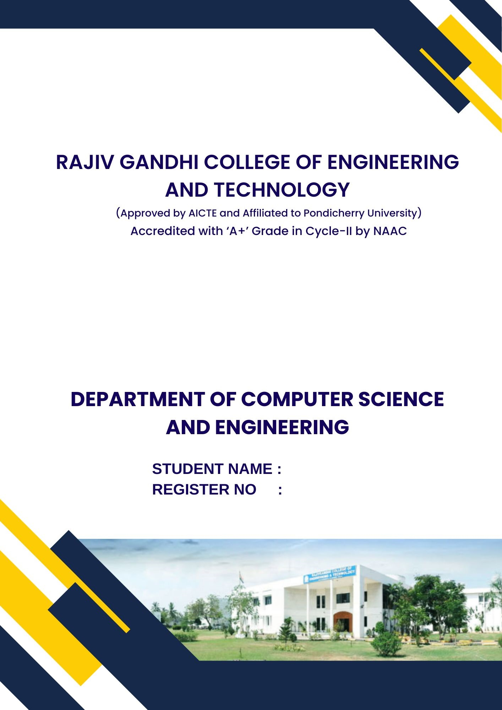
GENERAL PROFICIENCY - II (HS P65)


22TD0075
SANDEEP G

RAJIV GANDHI COLLEGE OF ENGINEERING
AND TECHNOLOGY
(Approved by AICTE and Affiliated to Pondicherry University)
Accredited with ‘A+’ Grade in Cycle-II by NAAC
Pondy – Cuddalore Main Road, Kirumampakkam, Puducherry - 607403

DEPARTMENT OF COMPUTER SCIENCE
AND ENGINEERING



Record Note Book

Name : SANDEEP G
Register No. : 22TD0075
Course : B. Tech (CSE)
Year / Semester : Y3/ S6
Subject & Code : GENERAL PROFICIENCY - II (HS P65)

RAJIV GANDHI COLLEGE OF ENGINEERING
AND TECHNOLOGY
(Approved by AICTE and Affiliated to Pondicherry University)
Accredited with ‘A+’ Grade in Cycle-II by NAAC
Pondy – Cuddalore Main Road, Kirumampakkam, Puducherry - 607403



DEPARTMENT OF COMPUTER SCIENCE AND ENGINEERING

BONAFIDE CERTIFICATE

This is to certify that the Bonafide record of practical work done by Mr. SANDEEP G, Reg. No. 22TD0075 pursuing Third year B.Tech. of Department of Computer Science and Engineering in GENERAL PROFICIENCY - II (HS P65) during the Academic Year 2024-2025.
Faculty In-charge | Head of the Department

